|  |  |  |  |  |  |  |  |  |
| --- | --- | --- | --- | --- | --- | --- | --- | --- |
| Forecast Values | |  |  |  | Compiler Engine Information | | |  |
|  |  |  |  |  |  |  |  |  |
| Stand ID: | | 894583 | | | GYPSY Model: | | 2009-May-21 | |
| Stand Type: | | Natural |  |  | Application: | | 20100713p | |
| Stand Age: | | 75 | years |  | COM DLL: | | 20100329b35 | |
| Spatial: | | NO |  |  |  |  |  |  |
| BA adjusted: | | YES |  |  |  |  |  |  |
|  |  |  |  |  |  |  |  |  |
| Input Data | |  |  |  |  |  |  |  |
|  |  |  |  |  |  |  |  |  |
| Species | | totage | topht | den | ps | ba | utilization | |
| AW |  | 75.0 | 13.54 | 298 |  | 7.02 | 13/7/30 | |
| SB |  |  |  |  |  |  | 15/10/30 | |
| SW |  | 64.0 | 13.54 | 156 |  | 3.68 | 13/7/30 | |
| PL |  | 58.0 | 13.54 | 34 |  | 0.8 | 13/7/30 | |
|  |  |  |  |  |  |  |  |  |
| Calculated Attributes | | |  |  |  |  |  |  |
|  |  |  |  |  |  |  |  |  |
| Species | | bhage | y2bh | si_bh | si_t | n0 | sdf | psi |
| AW |  | 68.8 | 6.2 | 11.1 | 10.1 | 407 | 343 |  |
| SB |  |  |  |  |  |  |  |  |
| SW |  | 53.4 | 10.6 | 12.9 | 10.6 | 158 | 157 |  |
| PL |  | 49.4 | 8.6 | 13.6 | 12.1 | 34 | 34 |  |

Tesera Gypsy

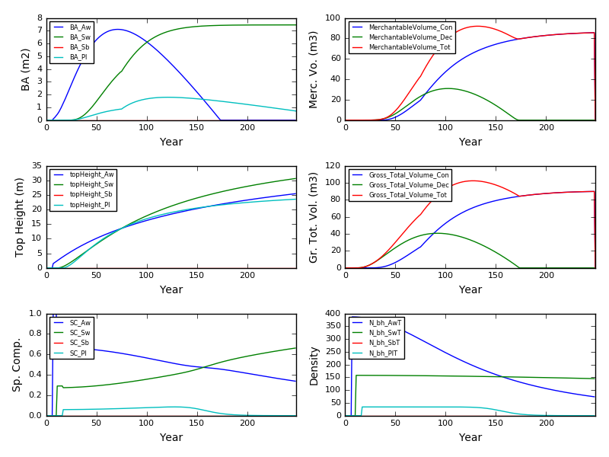

Excel Gypsy

